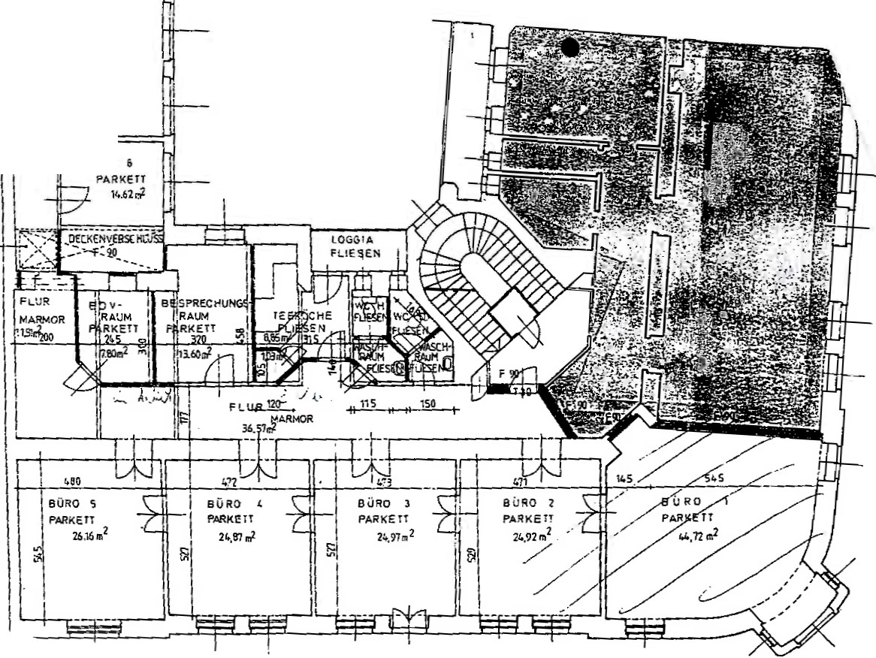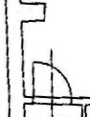

BURQ 7

PARKET'

2110.,,2_

SURO